4.51: a)
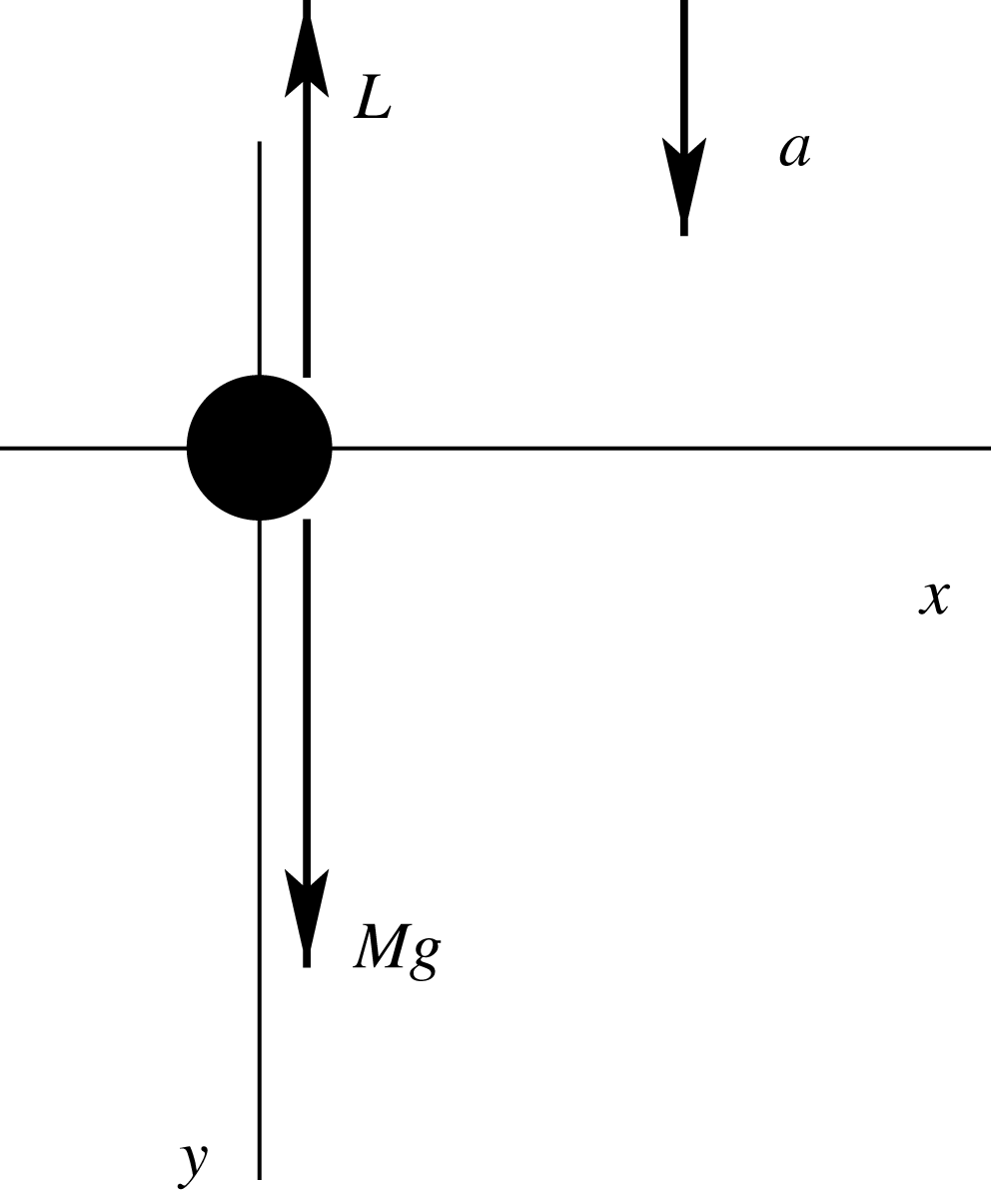
L is the lift force

b)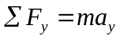
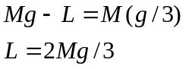

c) 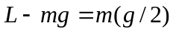, where m is the mass remaining.
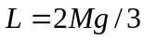, so 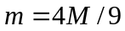. Mass 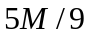 must be dropped overboard.

